

MAHENDRA ENGINEERING COLLEGE
(AUTONOMOUS)
Salem  Tiruchengode Highway
Mahendhirapuri, Mallasamudram, Namakkal DT -637 503.

Department of
Information Technology

LABORATORY RECORD

Certified to be the bonafide record of work done

By at

DATA STRUCTURES AND ALGORITHM Laboratory

During 2020 – 2021

His University Register Number is

Mrs.B.Bhuvaneshwari

Dr.K.Radha

Staff – in – Charge

Dr. S. Raju

Head of the Department

Date :

LISTOF EXPERIMENTS
1 | Array implementation of List, Stack and Queue ADTs
2 | Linked list implementation of List, Stack and Queue ADTs
3 | Applications of List, Stack and Queue ADTs
4 | Implementation of Binary Trees and operations of Binary Trees
5 | Implementation of Binary Search Trees
6 | To Develop the AVL Trees
7 | Implementation of Heaps using Priority Queues.
8 | Graph representation and Traversal algorithms
9 | Implementation of searching and sorting algorithms
10 | Hashing  any two collision techniques
11 | Implementation of 8-Queens problem using Backtracking method.

INDEX
S.No. | Date | Name of the Experiment | Marks | Signature
1 | 02/11/2020 | Array implementation of List, Stack and Queue ADTs
2 | 03/11/2020 | Linked list implementation of List, Stack and Queue ADTs
3 | 09/11/2020 | Applications of List, Stack and Queue ADTs
4 | 09/11/2020 | Implementation of Binary Trees and operations of Binary Trees
5 | 10/11/2020 | Implementation of Binary Search Trees
6 | 10/11/2020 | To Develop the AVL Trees
7 | 12/11/2020/ | Implementation of Heaps using Priority Queues.
8 | 12/11/2020 | Graph representation and Traversal algorithms
9 | 13/11/2020 | Implementation of searching and sorting algorithms
10 | 16/11/2020 | Hashing  any two collision techniques
11 | 16/11/2020 | Implementation of 8-Queens problem using Backtracking method.

EX.NO:1-a
LIST OPERATIONS USING ARRAY
DATE: 02/11/2020

AIM :
To write C program to perform list operation using array implementation.

ALGORITHM :

Step 1: Declare the variable and create the list ADT.
Step 2: Read the choice
Step 3: If the choice 1,
Perform insert operation, inserting the element into the list.
Step 4: If the choice 2,
Perform delete operation, deleting the element from the list
Step 5: If the choice 3,
Print the list element, Else Quit the Process.

PROGRAMS:
#include<stdio.h>
#include<conio.h>
#define MAX 10
void create();
void insert();
void deletion();
void search();
void display();
Void exit();
int a,b[20], n, p, e, f, i, pos;
void main()
{
//clrscr();
int ch;
char g='y';
do
{
printf("\n main Menu");
printf("\n 1.Create \n 2.Delete \n 3.Search \n 4.Insert \n 5.Display\n 6.Exit \n");
printf("\n Enter your Choice");
scanf("%d", &ch);
switch(ch)
{
case 1:
create();
break;
case 2:
deletion();
break;
case 3:
search();
break;
case 4:
insert();
break;
case 5:
display();
break;
case 6:
exit();
break;
default:
printf("\n Enter the correct choice:");
}
printf("\n Do u want to continue:::");
scanf("\n%c", &g);
}
while(g=='y'||g=='Y');
getch();
}
void create()
{
printf("\n Enter the number of nodes");
scanf("%d", &n);
for(i=0;i<n;i++)
{
printf("\n Enter the Element:",i+1);
scanf("%d", &b[i]);
}
}
void deletion()
{
printf("\n Enter the position u want to delete::");
scanf("%d", &pos);
if(pos>=n)
{
printf("\n Invalid Location::");
}
else
{
for(i=pos+1;i<n;i++)
{
b[i-1]=b[i];
}
n--;
}
printf("\n The Elements after deletion");
for(i=0;i<n;i++)
{
printf("\t%d", b[i]);
}
}
void search()
{
printf("\n Enter the Element to be searched:");
scanf("%d", &e);
for(i=0;i<n;i++)
{
if(b[i]==e)
{
printf("Value is in the %d Position", i);
}
else
{
printf("Value %d is not in the list::", e);
continue;
}
}
}
void insert()
{
printf("\n Enter the position u need to insert::");
scanf("%d", &pos);
if(pos>=n)
{
printf("\n invalid Location::");
}
else
{
for(i=MAX-1;i>=pos-1;i--)
{
b[i+1]=b[i];
}
printf("\n Enter the element to insert::\n");
scanf("%d",&p);
b[pos]=p;
n++;
}
printf("\n The list after insertion::\n");
display();
}
void display()
{
printf("\n The Elements of The list ADT are:");
for(i=0;i<n;i++)
{
printf("\n\n%d", b[i]);
}}

OUTPUT:

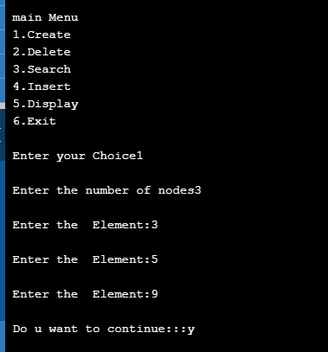

Result:
Thus the array implementation of list ADT was created and implemented successfully

EX.NO:1-b
STACK OPERATIONS USING ARRAY

DATE: 02/11/2020

AIM :
To write C program to perform stack operation using array implementation.

ALGORITHM :

Step 1: Declare the variable.
Step 2: Read the choice
Step 3: If the choice 1,
Perform push operation, inserting the element into the top of a stack.
Step 4: If the choice 2,
Perform pop operation, deleting the element from the top of a stack
Step 5: If the choice 3,
Print the stack element, Else Quit the Process.

PROGRAM:
#include<stdio.h>
#include<conio.h>
void main()
{
int ch,ch1,stack[10],top=-1,data,value,i;
clrscr();
do
{ printf("enter \n1.push \n2. pop");
scanf("%d",&ch1);
switch(ch1)
{
case 1:
printf("Enter data to insert in a stack\t");
scanf("%d",&data);
if(top==-1)
{
top++;
stack[top]=data;
}
else
{
top++;
stack[top]=data;
}
break;
case 2:
if(top==-1)
{ printf("stack is empty"); }
else
{
value=stack[top];
top--;
free(value);
}
break;
}
printf("\n press 1 to continue 2 to exit\n ");
scanf("%d",&ch);
}
while(ch==1);
printf("\n\ntop ->");
for(i=top;i>=0;i--)
{
printf("%d\n ",stack[i]);
}
getch();
}

Output:
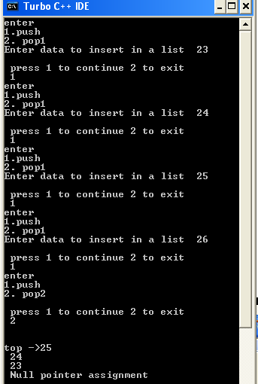

RESULT:
Thus the C program to perform array implementation of stack using stack ADT was executed.

EX.NO : 1 - c
QUEUE USING ARRAY
DATE: 02/11/2020

AIM:

To write a C program for Queue using array implementation.

ALGORITHM :

Step 1: Declare the variable.
Step 2: Read the choice
Step 3: If the choice 1,
Perform enque operation, inserting the element at end(rear) of the queue
Step 4: If the choice 2,
Perform deque operation, deleting the element from the front of the queue
Step 5: If the choice 3,
Print the queue element, Else Quit the Process.

PROGRAM:
#include<stdio.h>
#include<conio.h>
void main()
{
int ch,ch1,queue[10],front=-1,rear=-1,data,value,i;
clrscr();

do
{ printf("enter \n1.enqueue \n2. dequeue");
scanf("%d",&ch1);
switch(ch1)
{
case 1:
printf("Enter data to insert in a queue\t");
scanf("%d",&data);
if(front==-1)
{ front++;
rear++;
queue[rear]=data;
}
else
{ rear++;
queue[rear]=data;
}
break;
case 2:
if(front==-1)
{ printf("queue is empty"); }
else
{
value=queue[front];
front++;
free(value);
}
break;
}
printf("\n press 1 to continue 2 to exit\n ");
scanf("%d",&ch);
}
while(ch==1);
printf("\n\nfront ->");
for(i=front;i<=rear;i++)
{
printf(" %d",queue[i]);
}
printf("->rear");
getch();
}

OUTPUT;

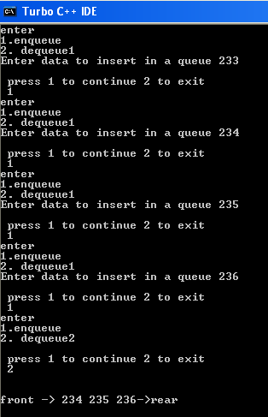

Result:

Thus the C program for queue ADT using array implementation was created, executed and output was verified successfully.

EX.NO: 2- a
STACK USING LINKED LIST
DATE: 03/11/2020
AIM :
To write C program to perform stack in linked list implementation.

ALGORITHM:
Step 1: Declare the variable.
Step 2: Read the choice
Step 3: If the choice 1,
Perform push operation, inserting the element into the top of a stack.
Step 4: If the choice 2,
Perform pop operation, deleting the element from the top of a stack
Step 5: If the choice 3,
Print the stack element, Else Quit the Process.

PROGRAM:

#include<stdio.h>
#include<conio.h>
struct node
{
int data;
struct node *next;
};
struct node *top=NULL;
void main()
{
int ch,ch1;
struct node *current, *newnode,*delnode;
clrscr();

do
{ printf("enter \n1.push \n2. pop");
scanf("%d",&ch1);
switch(ch1)
{
case 1:
printf("Enter data to insert in a stack\t");
newnode= (struct node *)malloc(sizeof(struct node));
scanf("%d",&newnode->data);
newnode->next=NULL;
if(top==NULL)
{
top=newnode;
}
else
{
newnode->next=top;
top=newnode;
}
break;
case 2:
if(top==NULL)
{ printf("stack is empty"); }
else
{
delnode=top;
top=delnode->next;
free(delnode);
}
break;
}
printf("\n press 1 to continue 2 to exit\n ");
scanf("%d",&ch);
}
while(ch==1);
printf("\n\ntop ->");
current=top;
while(current!=NULL)
{
printf("%d-> ",current->data);
current=current->next;
}
printf("NULL");
getch();
}

OUTPUT:

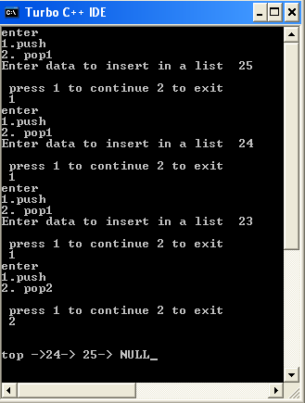

RESULT:
Thus the C program to perform linked link implementation of stack using stack ADT was executed.

EX.NO: 2 - b
QUEUE USING LINKED LIST
DATE: 03/11/2020

AIM :
To write a C program to perform queue operation using linked list implementation.

ALGORITHM :

Step 1: Declare the variable.
Step 2: Read the choice
Step 3: If the choice 1,
Perform enque operation, inserting the element at end(rear) of the queue
Step 4: If the choice 2,
Perform deque operation, deleting the element from the front of the queue
Step 5: If the choice 3,
Print the queue element, Else Quit the Process.

PROGRAM:

#include<stdio.h>
#include<conio.h>
struct node
{
int data;
struct node *next;
};
struct node *rear=NULL,*front=NULL;
void main()
{
int ch,ch1;
struct node *current, *newnode,*delnode;
clrscr();

do
{ printf("enter \n1.enque \n2. deque");
scanf("%d",&ch1);
switch(ch1)
{
case 1:
printf("Enter data to insert in a queue\t");
newnode= (struct node *)malloc(sizeof(struct node));
scanf("%d",&newnode->data);
newnode->next=NULL;
if(front==NULL)
{
front=newnode;
rear=newnode;
}
else
{
rear->next=newnode;
rear=newnode;
}
break;
case 2:
if(front==NULL)
{ printf("queue is empty"); }
else
{
delnode=front;
front=delnode->next;
free(delnode);
}
break;
}

printf("\n press 1 to continue 2 to exit\n ");
scanf("%d",&ch);
}
while(ch==1);
printf("\n\nfront ->");
current=front;
while(current!=NULL)
{
printf("%d-> ",current->data);
current=current->next;
}
printf("rear");
getch();
}

OUTPUT:

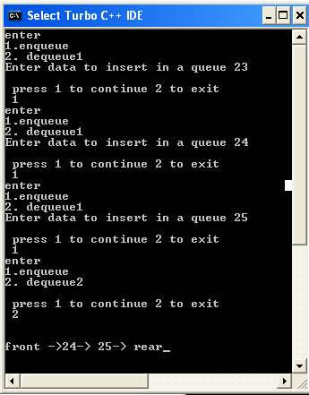

RESULT:
Thus C program to perform linked list implementation of queue operation is executed.

EX.NO: 3
INFIX TO POSTFIX NOTATION USING STACK

DATE: 09/11/2020

AIM:
To Write a C Program to perform infix to postfix conversion using stack.
ALGORITHM:
- Read the infix expression till end of file.
- If the symbol is an operand, place the operand in the output file.
- Else if the symbol is an operator or open parenthesis,
  - Place it onto the stack.
  - Read next symbol. If it is an operand, place the operand in output file else check precedence. If having higher precedence, then push it on to stack else pop stack symbol.
- Else if it is a right parenthesis ), Pop the stack until encountered the lower priority data.
- Else pop the entries from the stack until encountering the lower priority data.
- If it is the end of input, pop the stack until it is empty and place it onto the output file.

PROGRAM:
#define SIZE 50
#include <ctype.h>
char s[SIZE];
int top = -1;
push(char elem)
{
s[++top] = elem;
}
char pop()
{
return (s[top--]);
}
int pr(char elem)
{
switch (elem)
{
case '#':
return 0;
case '(':
return 1;
case '+':
case '-':
return 2;
case '*':
case '/':
return 3;
} }
main() {
char infx[50], pofx[50], ch, elem;
int i = 0, k = 0;
printf("-----Stack Application: Infix to Postfix Conversion-----\n");
printf("\n\nRead the Infix Expression ? ");
scanf("%s", infx);
push('#');
while ((ch = infx[i++]) != '\0')
{
if (ch == '(')
push(ch);
else if (isalnum(ch))
pofx[k++] = ch;
else if (ch == ' )' )
{
while (s[top] != ' ( ' )
pofx[k++] = pop();
elem = pop();
}
else {
while (pr(s[top]) >= pr(ch))
pofx[k++] = pop();
push(ch);
} }
while (s[top] != '#')
pofx[k++] = pop();
pofx[k] = '\0';
printf("\n\nGiven Infix Expn: %s Postfix Expn: %s\n", infx, pofx);
}

Output:
-----Stack Application: Infix to Postfix Conversion-----
Read the Infix Expression ? a+b*c-d

Given Infix Expn: a+b*c-d

Postfix Expn: abc*+d-

RESULT:
Thus the C program for infix to postfix conversion using stack is executed.

EX.NO: 4
BINARY SEARCH TREE.
DATE: 09/11/2020

AIM :

To write a C program to implement operation of binary search tree

ALGORITHM :
- Start the program
- Create binary search tree node
- Enter data want to be insert in a tree
- If tree is empty, enter as root node
- Else check data less than root node ,if insert it into left subtree
- Else insert it into right subtree
- Repeat the steps 4-5 until new data found
- Display Binary search tree using inorder
- Stop the program

PROGRAM:

#include <stdio.h>
#include <conio.h>

struct node
{
int value;
struct node* left;
struct node* right;
};

struct node* root;

struct node* insert(struct node* r, int data);
void inOrder(struct node* r);
int main()
{
struct node *root = NULL;
int i,n, v;
clrscr();
printf("How many data's do you want to insert ?\n");
scanf("%d", &n);
for(i=0; i<n; i++){
printf("Data %d: ", i+1);
scanf("%d", &v);
root = insert(root, v);
}

printf("Inorder Traversal: ");
inOrder(root);
printf("\n");
return 0;
getch();
}

struct node* insert(struct node* r, int data)
{
if(r==NULL)
{
r = (struct node*) malloc(sizeof(struct node));
r->value = data;
r->left = NULL;
r->right = NULL;
}

else if(data < r->value){
r->left = insert(r->left, data);
}
else {
r->right = insert(r->right, data);
}
return r;

}

void inOrder(struct node* r)
{
if(r!=NULL){
inOrder(r->left);
printf("%d ", r->value);
inOrder(r->right);
}
}

OUTPUT:

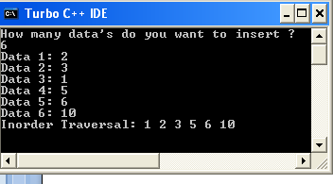

RESULT:
Thus the C program to implement operation of binary search tree was executed

EX.NO : 5
TREE TRAVERSING
DATE: 10/11/2020
AIM:
To write a C program to implement Tree traversal in binary tree.
ALGORITHM :
- Start the Program
- Specify the number of items to be inserted and enter the data
- Perform inorder traversal by process the root node, traverse the left subtree and then right subtree
- Perform preorder traversal by traverse the left subtree , process the root node and then right subtree
- Perform postorder traversal by traverse the left subtree , then right subtree and process the root node.
- Display the result
- Stop the program

PROGRAM:
#include<stdio.h>
#include<conio.h>
#include<alloc.h>
struct btreenode
{
struct btreenode *leftchild;
int data;
struct btreenode *rightchild;
};
void insert(struct btreenode**,int);
void inorder(struct btreenode*);
void preorder(struct btreenode*);
void postorder(struct btreenode*);
void main()
{
struct btreenode *bt;
int req,i=1,num;
bt=0;
clrscr();
printf(" specify the number of items to be inserted ");
scanf("%d",&req);
while(i++<=req)
{
printf("enter the data :");
scanf("%d",&num);
insert(&bt,num);
}
printf("\n inorder traversal");
inorder(bt);
printf("\n preorder traversal");

preorder(bt);
printf("\n postorder traversal");
postorder(bt);
getch();
}
void insert(struct btreenode **sr,int num)
{
if(*sr==0)
{
*sr=malloc(sizeof(struct btreenode));
(*sr)->leftchild=NULL;
(*sr)->data=num;
(*sr)->rightchild=NULL;
return;
}
else
{
if(num<(*sr)->data)
insert(&((*sr)->leftchild),num);
insert(&((*sr)->rightchild),num);
}
return;
}
void inorder(struct btreenode *sr)
{
if(sr!=0)
{
inorder(sr->leftchild);
printf("\t %d",sr->data);
inorder(sr->rightchild);
}
else
return;
}
void preorder(struct btreenode *sr)
{
if(sr!=0)
{
printf("\t %d",sr->data);
preorder(sr->leftchild);
preorder(sr->rightchild);
}
else
return;
}
void postorder(struct btreenode *sr)
{
if(sr!=0)
{
postorder(sr->leftchild);
postorder(sr->rightchild);
printf("\t %d",sr->data);
}
else
return;
}

OUTPUT:
Enter the number of items to be inserted 3
Enter the data 34
Enter the data 45
Enter the data 65
Inorder traversal 34 45 65
Preorder traversal 34 45 65
Postorder traversal 65 45 34

RESULT:
Thus the C program for to implement Tree traversal in binary tree was executed

EX.NO: 6
MERGE SORT

DATE: 10/11/2020

AIM:
To Write a C Program to perform merge sort in the given array.

ALGORITHM:

- Start the program
- Get the n elements to be sorted
- Divide the list recursively into two halves until it can no more be divided
- merge the smaller lists into new list in sorted order
- Merge the list until all the element get sorted
- Print the sorted array
- Stop the program

PROGRAM:

#include <stdio.h>
#define max 10
int a[11] = { 10, 14, 19, 26, 27, 31, 33, 35, 42, 44, 0 };
int b[10];
void merging(int low, int mid, int high) {
int l1, l2, i;
for(l1 = low, l2 = mid + 1, i = low; l1 <= mid && l2 <= high; i++)
{
if(a[l1] <= a[l2])
b[i] = a[l1++];
else
b[i] = a[l2++];
}
while(l1 <= mid)
b[i++] = a[l1++];
while(l2 <= high)
b[i++] = a[l2++];
for(i = low; i <= high; i++)
a[i] = b[i];
}
void sort(int low, int high)
{
int mid;
if(low < high) {
mid = (low + high) / 2;
sort(low, mid);
sort(mid+1, high);
merging(low, mid, high);
} else {
return;
}
}

int main() {
int i;
printf("List before sorting\n");
for(i = 0; i <= max; i++)
printf("%d ", a[i]);
sort(0, max);
printf("\nList after sorting\n");
for(i = 0; i <= max; i++)
printf("%d ", a[i]);
}

OUTPUT:

List before sorting
10 14 19 26 27 31 33 35 42 44 0
List after sorting
0 10 14 19 26 27 31 33 35 42 44

RESULT: Thus the C program for Sorting the elements in the array using merge sort was executed and output was verified.

EX. NO: 7
BUBBLE SORT
DATE: 12/11/2020

AIM:
To Write a C Program to perform bubble sort in the given array.
ALGORITHM:

1. Get the n elements to be sorted.
2. Compare the first two elements of the array and swap if necessary.
3. Then, again second and third elements are compared and swapped if it is necessary and continue
this process until last and second last element is compared and swapped.
4. Repeat the above two steps n-1 times and print the result.

PROGRAM
#include<stdio.h>
int main()
{
int s,temp,i,j,a[20];
printf("Enter total numbers of elements: ");
scanf("%d",&s);
printf("Enter %d elements: ",s);
for(i=0;i<s;i++)
scanf("%d",&a[i]);
//Bubble sorting ALGORITHM
for(i=s-2;i>=0;i--)
{ for(j=0;j<=i;j++)
{
if(a[j]>a[j+1])
{
temp=a[j];
a[j]=a[j+1];
a[j+1]=temp;
} } }
printf("After sorting: ");
for(i=0;i<s;i++)
printf(" %d",a[i]);
return 0;
}

OUTPUT:
Enter total numbers of elements: 5
Enter 5 elements: 6 2 0 11 9
After sorting: 0 2 6 9 11

RESULT:
Thus the C program for Sorting the elements in the array using Bubble sort was executed and output was verified.

EX.NO: 8 - a

BINARY SEARCH AND SEQUENTIAL SEARCH.

DATE: 12/11/2020

a. Sequential Search

AIM :
To write a C program to search an element in array using linear search algorithm.
ALGORITHM :
- Start the program
- Declare array variable
- Get elements of an array from user
- Enter the value to search (c)
- compare the element ( c ) with all the elements given in the array
- if the element is matched it returns its position
- Stop the program

PROGRAM :

#include<stdio.h>
#include<conio.h>
void main()
{
int a[10],c,i;
clrscr();
printf("Enter the elements of an array:");
for(i=0;i<10;i++)
{
scanf("%d",&a[i]);
}
printf("\n Enter the value to search");
scanf("%d",&c);
for(i=0;i<10;i++)
{
if(c==a[i])
{ printf("\n Element found"); break; }
}
printf("Element c=%d is in the position=%d",c,i);
getch();
}

OUTPUT :

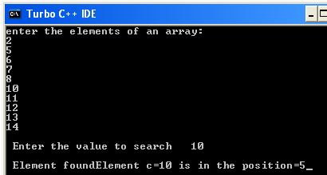

RESULT
Thus the C program to search an element in array using linear search algorithm was executed.

EX.NO : 8 - b
b. Binary Search
DATE : 12/11/2020

AIM :
To write a C program to search an element in array using binary search algorithm.
ALGORITHM :
- Start the program
- Declare array variable
- Get elements of an array from user
- Read the search element from the user
- Compare the search element with the middle element in the sorted list
- If both are matching, then display its position
- Else, If the search element is < middle element, then repeat steps 4, 5 & 6 for the left sublist of the middle element
- If the search element is > middle element, then repeat steps 24, 5 & 6 for the right sublist of the middle element
- Repeat the same process until find the search element
- if the element is matched it returns its position
- Stop the program

PROGRAM :
#include<stdio.h>
#include<conio.h>
void main()
{
int i, a[10], search, first, last, middle;
clrscr();
printf("Enter the elements of an array ");
for (i=0; i<10; i++)
{
scanf("%d",&a[i]);
}
printf("Enter a number to find :");
scanf("%d", &search);
first = 0;
last = 10-1;
middle = (first+last)/2;
while (first <= last)
{
if(a[middle] < search)
{ first = middle + 1; }
else if(a[middle] == search)
{
printf("%d found at location %d\n", search, middle);
break;
}
else
{ last = middle - 1; }
middle = (first + last)/2;
}
if(first > last)
{
printf("search element not found");
}
getch();
}

OUTPUT :

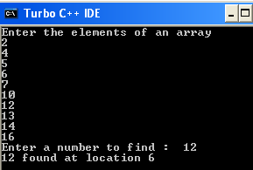

RESULT : Thus the C program to search an element in array using binary search algorithm was executed.
EX.NO: 9 - a
BREADTH FIRST SEARCH
DATE: 13/11/2020

AIM:
To write a C Program to implement breadth first search Algorithm
ALGORITHM:
- Start the program
- Enter number of vertices and adjacency matrix of the graph
- Pick a starting vertex (a) and mark it as visited
- Find all the vertex along the path which begins with vertex A that has not been visited yet
- Process all the vertex and mark it as visited
- Repeat step 4 and 5 until unmarked vertex found
- If all node marked as visited, display the result
- Stop the program
PROGRAM:

#include<stdio.h>
#include<conio.h>
int a[20][20],q[20],visited[20],n,i,j,f=0,r=-1;
void bfs(int v)
{
for(i=1;i<=n;i++)
if(a[v][i] && !visited[i])
q[++r]=i;
if(f<=r)
{
visited[q[f]]=1;
bfs(q[f++]);
}
}
void main()
{
int v;
clrscr();
printf(" Enter the number of vertices:");
scanf("%d",&n);
for(i=1;i<=n;i++)
{
q[i]=0;
visited[i]=0;
}
printf("\n Enter graph data in matrix form:");
for(i=1;i<=n;i++)
for(j=1;j<=n;j++)
scanf("%d",&a[i][j]);
printf(" Enter the starting vertex:");
scanf("%d",&v);
bfs(v);
printf("The node which are reachable are:");
for(i=1;i<=n;i++)
if(visited[i])
printf("%d ",i);
else
printf("n Bfs is not possible");
getch();
}

OUTPUT:

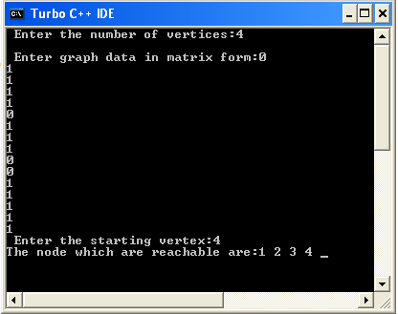

RESULT:
Thus a C Program to implement breadth first search Algorithm was executed

EX.NO: 9 – b
DEPTH FIRST SEARCH

DATE: 13/11/2020

AIM:
To write a C Program to implement depth first search Algorithm

ALGORITHM:

1. Start the program
2. Enter number of vertices and adjacency matrix of the graph
3. Pick a starting vertex (a) and mark it as visited
4. Find another vertex along the path which begins with vertex A that has not been visited yet
5. Process the vertex and mark it as visited
6. Repeat step 4 and 5 until unmarked vertex found
7. If still graph contain unvisited node, use backtracking and continue the search
8. If all node marked as visited, display the result
9. Stop the program
PROGRAM:

#include<stdio.h>

void DFS(int);
int G[10][10],visited[10],n; //n is no of vertices and graph is sorted in array G[10][10]

void main()
{
int i,j;
printf("Enter number of vertices:");

scanf("%d",&n);

//read the adjecency matrix
printf("\nEnter adjecency matrix of the graph:");

for(i=0;i<n;i++)
for(j=0;j<n;j++)
scanf("%d",&G[i][j]);

//visited is initialized to zero
for(i=0;i<n;i++)
visited[i]=0;

DFS(0);
}

void DFS(int i)
{
int j;
printf("\n%d",i);
visited[i]=1;

for(j=0;j<n;j++)
if(!visited[j]&&G[i][j]==1)
DFS(j);
}

OUTPUT:

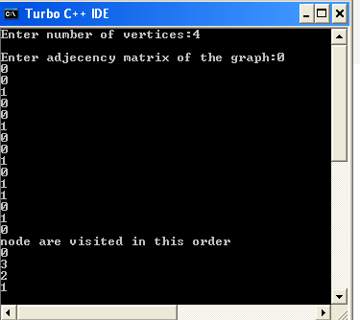

RESULT:

Thus a C Program to implement depth first search Algorithm was executed

EX.NO: 10
HASHING FUNCTION
DATE: 16/11/2020

AIM:
To write a C Program to implement hashing function

ALGORITHM:

1. Start the program
2. Enter number of values to be inserted in the hash table with hash size
3. Enter the hash table size
4. Space is allocated for values in hash table
5. Process the values to be stored in hash table with the limit
6. Repeat step 4 and 5 until the hash table size exceeds and continue search
8. If all values marked as visited, display the result
9. Stop the program

PROGRAM:
Separate Channing :-
#include<stdio.h>
#include<stdlib.h>

#define size 7

struct node
{
int data;
struct node *next;
};

struct node *chain[size];

void init()
{
int i;
for(i = 0; i < size; i++)
chain[i] = NULL;
}

void insert(int value)
{
//create a newnode with value
struct node *newNode = malloc(sizeof(struct node));
newNode->data = value;
newNode->next = NULL;

//calculate hash key
int key = value % size;

//check if chain[key] is empty
if(chain[key] == NULL)
chain[key] = newNode;
//collision
else
{
//add the node at the end of chain[key].
struct node *temp = chain[key];
while(temp->next)
{
temp = temp->next;
}

temp->next = newNode;
}
}

void print()
{
int i;

for(i = 0; i < size; i++)
{
struct node *temp = chain[i];
printf("chain[%d]-->",i);
while(temp)
{
printf("%d -->",temp->data);
temp = temp->next;
}
printf("NULL\n");
}
}

int main()
{
//init array of list to NULL
init();

insert(7);
insert(0);
insert(3);
insert(10);
insert(4);
insert(5);

print();

return 0;
}

OUTPUT :

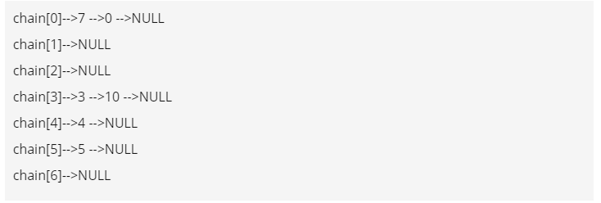

Result:
Thus the c program for implementation of hashing function has been created and executed successfully.

EX.NO:11

Implementation of 8-Queens problem using Backtracking
method.
DATE: 16/11/2020

AIM :
To write a C program for implement 8 queen’s problem using backtracking method.

Algorithm:

- Start in the left most column.
- If all queens are placed and return true.
- Try all rows in the current column and Do following for every tried row.
  - If the queen can be placed safely in this row, then mark this[row, column] as part of the solution and recursively check if placing queen here leads to a solution.
  - If placing the queen in [row, column] leads to a solution then return true.
  - If placing queen doesn’t lead to solution then unmark this [row, column] and go to step (a) to try other rows.
- If all rows have been tried and nothing worked return false to trigger backtracking.
- Stop the process.

PROGRAM:

#include<stdio.h>
#include<stdlib.h>
int t[8] = {-1};
int sol = 1;

void printsol()
{
int i,j;
char crossboard[8][8];
for(i=0;i<8;i++)
{
for(j=0;j<8;j++)
{
crossboard[i][j]='_';
}
}
for(i=0;i<8;i++)
{
crossboard[i][t[i]]='q';
}

for(i=0;i<8;i++)
{
for(j=0;j<8;j++)
{
printf("%c ",crossboard[i][j]);
}
printf("\n");
}
}
int empty(int i)
{
int j=0;
while((t[i]!=t[j])&&(abs(t[i]-t[j])!=(i-j))&&j<8)j++;
return i==j?1:0;
}

void queens(int i)
{
for(t[i] = 0;t[i]<8;t[i]++)
{
if(empty(i))
{
if(i==7){
printsol();
printf("\n solution %d\n",sol++);
}
else
queens(i+1);
}
}
}

int main()
{
queens(0);
return 0;
}

OUTPUT:

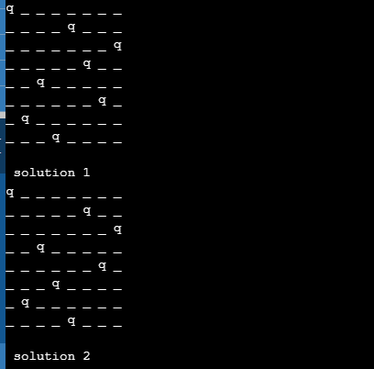

Result :
Thus the C program for 8 Queen’s problem using backtracking method was executed successfully.

